Question:
a) Define working capital and cash flow.
Answer:
Working Capital is the difference between current assets (e.g., cash, inventory) and current liabilities (e.g., accounts payable). It represents the resources available to finance daily operations. In simpler terms, it’s the cash needed to keep the business running smoothly on a day-to-day basis.
Cash Flow is the net amount of cash coming in and going out over a period. Positive cash flow means more cash was received than spent, and negative cash flow means more cash was spent than received. Cash flow is critical for assessing a business's ability to meet short-term financial obligations.

Question:
b) A small web development company needs to estimate cash flow for the first six months. How would you create a cash flow forecast, and what assumptions would you make?
Answer:
To create a six-month cash flow forecast:
- Revenue Assumptions:
  - Contracted revenue of £10,000/month for the first three months.
  - New sales for months 4, 5, and 6, generating £8,000, £10,000, and £12,000 respectively.
- Cost Assumptions:
  - Fixed Costs: Office rent, utilities, and admin at £2,000/month.
  - Variable Costs: Employee wages and tech costs at £3,000/month.
  - Miscellaneous Costs: Marketing, software, and internet at £500/month.
Forecast Example:
Question:
ii) How do you use this forecast to estimate the working capital needed?
Answer:
To estimate working capital:
- Calculate Minimum Cash Needs: Ensure at least one month of costs (fixed, variable, miscellaneous) covered, totaling £5,500.
- Add Safety Margin: To allow for unexpected costs, an additional buffer of £10,000 is recommended at the start.
Thus, an initial working capital of around £10,000 would cover the business's monthly cash requirements and provide stability.
Budget:
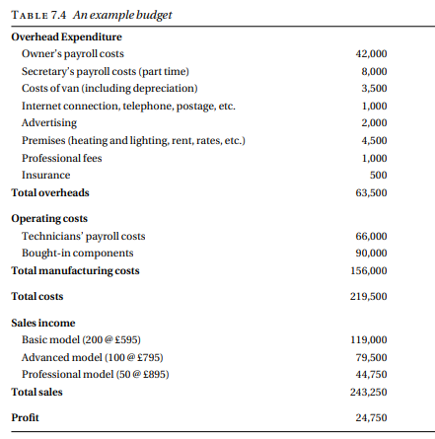

Cash flow forecast:
The figures in each cell show the amount of cash entering or leaving the company during that month, under the heading given at the left-hand end of each row. Thus the figure of £500 given in the ‘January’ column and the ‘Insurance’ row means that an insurance premium of £500 will be paid sometime in January. The figure of £7,000 in the ‘March’ column and the ‘Income from trade sales’ row means that £7,000 will enter the company’s bank account in March as a result of trade customers paying invoices. The timing of the payments is important and it depends on commercial practice. Thus rents are normally paid quarterly, in advance. Hence the rent payment will be made at the beginning of January and the beginning of April. Components will probably be bought against credit accounts with one or more suppliers. Under such arrangements, invoices for components delivered in one month will be issued at the end of that month and customers will be expected to pay the invoice within 28 days of its being issued. Similar arrangements will probably apply to energy costs but these will reduce as we move from the cold winter months into the warmer season.
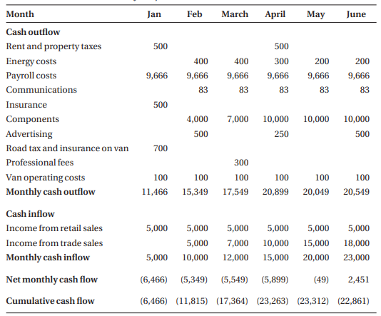
DCF:
As an example of simple DCF analysis, consider a small computer maintenance company. The company has one van that it uses for transporting computers that cannot be repaired on site to and from its workshop. When things are busy, the one van is not enough and the company often has to rent a second van. It is considering whether it is worthwhile to buy a second van. A new van will cost £10,000. There will be annual costs of £500 for insurance and £150 for road tax. The cost of maintenance is estimated to be £200 in each of the first two years, £300 in year 3, £400 in year 4 and £500 in year 5. At the end of the fifth year, it is expected that the van will be sold for around £2,000. The interest rate that the company pays on its borrowings is 10 percent. Van hire costs £30 per day and it hires a van for about 100 days a year. All the costs are subject to inflation, which is judged to be around 5 per cent over the period, but the resale value of the van is the cash figure expected at the time. Table 8.2 shows the cash flows in the two cases. Most of the figures are in brackets, indicating negative cash flows, because the flows of cash are out of the company.
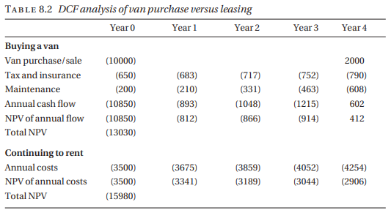
ASSESSMENT OF A SOFTWARE PRODUCT PROPOSAL:
As a more sophisticated example, we consider a company that is assessing a proposal for the development of a software product. It is estimated that three people will be required for development in the first year and a further person and a half in the second year; suitable staff cost £35,000 per year, including the employer’s pension and national insurance costs. The product will be released in the second year. After the second year, maintenance is expected to require one person, full-time. Sales and marketing costs are estimated to be £20,000 in the first year, rising to £30,000 for each of the next four years. The product itself is a fairly high-value but specialized product. It is expected that about 100 copies will be sold over this period, at around £5,000 a copy. Table 8.3 shows the DCF analysis of the project over a five-year period, using 10 per cent as the (monetary) cost of capital.
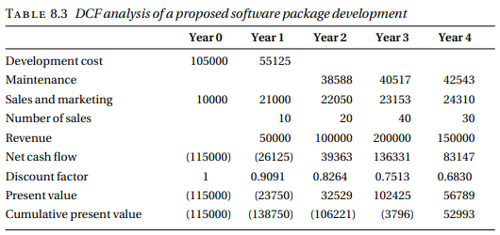

Question:
Bell and Sons are a specialist food wholesaler. They purchase products in bulk from producers around the world and sell to local shops across the country. Their stock control is currently done manually, but they have found as the company has grown that more problems have occurred with stock-outs and food items going beyond their sell-by date. To solve this problem the company management is investigating two software options: a general stock control package (StockIT) and a specialist food stock control package (FoodStore). StockIT could be installed on the organization’s existing file server and does not require specialist customization, so it is cheaper than FoodStore to install. However, FoodStore provides a better match to the organization’s requirements and therefore is expected to deliver greater benefit. The anticipated costs and benefits are shown in Table 8.4 below. The company is borrowing the money to finance the purchase of the software. The cost of capital is 20%. You should assume annual costs and benefits commence the year after the installation
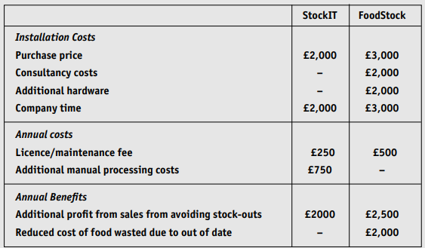
Perform the following types of cost-benefit analysis to show which package Bell and Sons should buy.
a) simple payback analysis to show the length of the payback period; [8 marks]
Simple payback analysis to show the length of the payback period. Ignoring the time value of money, the payback period is the installation cost divided by the annual benefit. For StockIT, the net annual benefit is £1000 and the installation cost is £4000. Hence the simple payback period is 4000/1000, that is, four years. For FoodStore, the net annual benefit is £4000 and the installation cost is £10000. Hence the simple payback period is 10000/4000, that is, 2.5 years.
b) simple return-on-investment to show the average rate of return; [8 marks]
Ignoring the time value of money, the simple return on investment is the net annual benefit divided by the investment that is 1000/4000 = 25 per cent for StockIT and 4000/10000 = 40 per cent for Foodstore.
c) net present value from the discounted cash flow over the four years after implementation
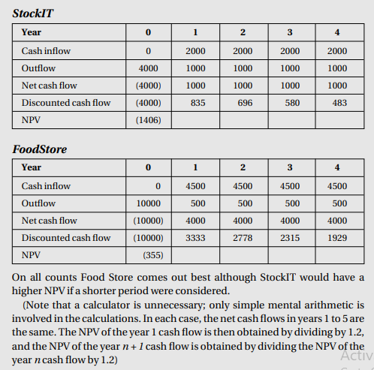
Question:
Pontevedro Software produces a range of packages for project management, accounting, and cost estimation in the construction industry. It is currently developing a new package for computeraided drafting that will interface with the cost estimation package. It currently employs some 200 professional staff. The packages are sold in the UK, North America and Australia but the company is keen to expand into Asia and into mainland Europe. The organizational structure of the company is more or less the same as when it was a company with 20 staff, operating only in the UK, and the directors have decided that a fundamental reorganization is necessary. Discuss the main decisions that have to be taken before the new organization can be set up.
Ans:
The decision to reorganize Pontevedro Software's structure as it grows into new markets is crucial for optimizing operational efficiency, enhancing product relevance, and ensuring effective customer support across diverse regions. Given the company’s current focus areas—project management, accounting, cost estimation, and an emerging computer-aided drafting package—several core organizational decisions should guide this restructuring process.

Key Structural Considerations
- Organizational Basis:
  - Functional, Product, or Geographic Focus: The fundamental choice is whether to structure the organization by function (e.g., sales, development, support), by product line, or by geographic region. In this case, a hybrid approach incorporating elements of each may be ideal, allowing Pontevedro Software to balance specialization with local adaptability.
- Functional Top-Level Divisions:
  - The company could establish three primary functional divisions:
    - Sales and Marketing: This division could be organized geographically, with dedicated teams for each major region—UK, North America, Australia, Asia, and Europe—ensuring tailored sales approaches and regional marketing strategies.
    - Development and Production: This division may benefit from being subdivided into customer support, maintenance and enhancement of existing products, and the development of new products. Separating these areas can streamline product innovation while maintaining quality and consistency in customer service and ongoing product updates.
    - Administration: This division would centralize HR, finance, and legal operations, supporting the organization’s global needs.
- Sales and Marketing Adaptation:
  - Regional Presence: Since sales and marketing require a close understanding of each region, Pontevedro may establish regional hubs with teams familiar with local business practices, languages, and industry standards.
  - Customer-Centric Approach: Each regional unit could have an attached customer support team to address specific language and industry norms, especially for high-demand regions like Asia and Europe, where localization will be critical to market entry.
- Product Development Considerations:
  - Localized Product Adaptation: Different regions may have unique construction standards, regulatory requirements, and industry practices. It may be beneficial to establish satellite product development centers in key regions to address these differences effectively.
  - Multilingual and Multicultural Support: In addition to technical adaptations, the new package should include language support and align with local regulations and preferences, especially in emerging markets.
  - Innovation and R&D Centers: In major regions, having localized R&D can help in developing new, market-specific products and incorporating regional insights into global product lines.
- Customer Support Strategy:
  - Regional Support Centers: For effective customer support, it may be necessary to establish dedicated customer support units attached to the main sales units in each region, particularly in regions where language and cultural barriers exist.
  - 24/7 Global Support: Implementing a global, round-the-clock support system can ensure seamless assistance across time zones, enhancing the customer experience worldwide.
- Scalability and Flexibility:
  - Scalable Structure for Growth: The reorganization should allow Pontevedro to scale smoothly as it continues to grow and enter new regions. A flexible structure, adaptable to market changes and emerging needs, will be essential for long-term success.

Summary
In conclusion, an ideal reorganization for Pontevedro Software should incorporate a top-level functional structure, with divisions for sales and marketing, development and production, and administration. Within sales and marketing, a regional approach is vital to cater to each market’s unique requirements. Development and production should support existing products, pursue innovation, and provide localized support as needed. By embedding flexibility and regional focus, Pontevedro will be well-positioned to achieve sustainable growth and effectively serve an increasingly diverse global customer base.
Question:
Syniad Software plc is a large and successful producer of professional level desk-top publishing packages. It operates globally and produces versions of its packages for eight different alphabets. Discuss the different ways in which the organization might be structured, paying particular reference to the relationship between the research and development function on the one hand, and sales, marketing and customer support on the other.
Ans:
Given Syniad Software plc’s global reach and its production of desk-top publishing (DTP) packages for eight different alphabets, the organizational structure needs to support the company’s ability to deliver customized, regionally relevant products while maintaining streamlined global operations. A well-designed structure should integrate the Research and Development (R&D) function closely with sales, marketing, and customer support, ensuring responsiveness to market needs and efficient product localization.

Possible Organizational Structures for Syniad Software plc
- Matrix Structure: Cross-Functional Collaboration
  - In a matrix structure, R&D, sales, marketing, and customer support teams collaborate closely across projects, which in this case would be language or alphabet-specific versions of the DTP packages. Teams for each alphabet or region would include representatives from each functional area, ensuring that market insights directly influence product design and development.
  - Advantages:
    - High level of coordination between R&D and customer-facing functions, enabling rapid response to regional market demands and feedback.
    - Cross-functional teams can specialize in specific alphabets and cultures, providing nuanced insight for product localization and marketing strategies.
  - Challenges:
    - A matrix structure can be complex to manage, requiring clear roles and coordination to avoid conflicts in resource allocation or project prioritization.
- Product-Based Divisional Structure: Alphabet-Focused Units
  - In this structure, the organization is divided into units based on product versions aligned with specific alphabets or regions. Each product division would house R&D, marketing, sales, and customer support functions, allowing it to operate almost autonomously and focus on the specific linguistic and cultural requirements of its target users.
  - Advantages:
    - Focused expertise within each product division, enabling deep alignment of product features, marketing messages, and support approaches with the needs of each linguistic group.
    - Faster decision-making within each division as all functions relevant to the product’s success are managed within the division itself.
  - Challenges:
    - Risk of duplicated efforts across divisions, such as overlapping R&D work that could be standardized or shared.
    - Maintaining consistent global brand standards may require additional oversight.
- Geographical Divisional Structure: Regional Focus with Centralized R&D
  - Syniad could structure its organization around geographical regions (e.g., North America, Europe, Asia) to align closely with the regional market demands. In this model, R&D would remain centralized to focus on core product development, but each regional division would handle localization, marketing, sales, and customer support tailored to local needs.
  - Advantages:
    - Regional teams can adapt global products to fit local markets more effectively, improving user relevance and market reach.
    - Centralized R&D can maintain overall product coherence and capitalize on economies of scale by creating a strong, unified core product before localization.
  - Challenges:
    - Potential disconnect between centralized R&D and regional market needs, which may lead to slower adaptation of product features or updates in response to regional feedback.
    - Regional teams may face limitations in influencing the core product roadmap.
- Hybrid Structure: Functional R&D with Regional and Product Integration
  - A hybrid structure would integrate the functional and regional approaches, centralizing R&D for core product development and regionalizing customer-facing functions like sales, marketing, and customer support. Product managers for each alphabet or region could act as liaisons between R&D and the market-specific teams.
  - Advantages:
    - Combines the strengths of a centralized R&D function with regional market responsiveness, ensuring that products are well-tailored for each target audience.
    - Product managers act as a bridge, helping translate market needs into product features and updates, enhancing customer satisfaction.
  - Challenges:
    - Requires careful coordination to ensure that the feedback from each regional team is effectively communicated to R&D and prioritized appropriately.
    - Success depends on the effectiveness of product managers in facilitating collaboration between functions.

Relationship Between R&D and Customer-Facing Functions
Regardless of the structure chosen, the relationship between R&D and the customer-facing functions is critical to Syniad’s success:
- Feedback Loop: R&D must establish a strong feedback loop with sales, marketing, and customer support to ensure the product remains aligned with customer needs and market trends. This feedback could include requests for features, bug reports, and suggestions for improvements, especially critical given the linguistic and cultural differences across markets.
- Localization: R&D should work closely with regional marketing teams to customize products for different alphabets and cultural nuances, such as adapting interface design, language support, and relevant features.
- Product Updates and Innovations: Marketing insights into emerging trends or competitor analysis can inform R&D’s roadmap, enabling Syniad to maintain its edge in the DTP market by delivering innovative, customer-centric solutions.
- Coordination and Communication: Clear communication channels are essential to keep all functions aligned on product objectives, timelines, and customer expectations, particularly in a global company where the complexity of operating across regions can challenge cohesion.

Conclusion
For Syniad Software plc, a hybrid structure may provide the most balanced approach, combining centralized R&D with regionalized sales, marketing, and customer support, while product managers serve as intermediaries. This setup can enable Syniad to innovate efficiently, respond flexibly to regional demands, and maintain a global brand presence.

HR:
Question 1
Q: Explain the different purposes of an appraisal system.
[4 marks]
A: Appraisal systems have three primary purposes:
- Monitoring Performance – Assessing how well employees meet their job requirements and objectives.
- Career Planning – Assisting employees in their career development by identifying growth opportunities and career paths.
- Assessing Training Needs – Identifying areas where employees may benefit from additional training to improve job performance.

Question 2
Q: Describe a suitable generic appraisal process, showing how this might affect the style of the appraisal.
[15 marks]
A: A generic appraisal process consists of three phases:
- Preparation:
  - This is an ongoing process involving the setting of objectives and tracking relevant actions since the last appraisal.
  - For the appraisal meeting, both parties should prepare by reviewing past performance and setting expectations for the upcoming period.
- Appraisal Meeting:
  - A discussion of past performance, identifying areas for improvement.
  - Address training needs for performance improvement and career progression.
  - New or revised objectives are agreed upon to guide future performance.
- Documentation:
  - The appraisal is documented by one party, reviewed, and signed off by both.
The appraisal style depends on its primary purpose. If focused on staff development and career planning, the appraisal is likely to be more open and collaborative. However, if it emphasizes monitoring progress or pay and promotions, it may be more formal and potentially contentious.

Question 3
Q: What influence would your membership of the BCS have on the preparation for your own appraisal?
[6 marks]
A: Membership in the British Computer Society (BCS) encourages professionals to take responsibility for their development, stay informed about new technologies, and improve competencies. This includes:
- Ensuring appraisal discussions cover personal development and improvement areas.
- Adhering to Continuous Professional Development (CPD) guidelines, which encourage maintaining documentation for skills and professional growth.
- Accountability for responsibilities, improving self-awareness of one’s limitations and strengths.

Question 4
Q: Explain the ideas of job rotation, job enlargement, and job enrichment, illustrating how they might be applied to Peter, Paul, and Mary’s roles in the university’s accounting department.
[15 marks]
A: The concepts of job rotation, job enlargement, and job enrichment can enhance employees' engagement and skills:
- Job Rotation:
  - Employees rotate through different roles periodically, broadening skills and reducing monotony.
  - In this scenario, Peter, Paul, and Mary could switch roles within the invoice handling process, allowing each to experience various tasks, such as receiving invoices, marking approvals, and preparing invoices for payment.
- Job Enlargement:
  - Expanding job scope by adding related tasks to an employee's role.
  - For instance, Peter’s role could be expanded to include invoice approval, adding responsibility and reducing dependency on Paul for specific tasks.
- Job Enrichment:
  - Increasing responsibilities and independence in a role, making work more meaningful.
  - Mary’s role could be enriched by giving her the authority to resolve payment issues, fostering a sense of ownership and deeper involvement in the process.

Question 5a
Q: Birchall (1975) states that ‘job enrichment is aimed at increasing the worker’s involvement in the organization and/or the job’. In the case of a computer programmer having their job enriched by including team leader responsibilities, list five issues that management needs to consider.
[5 marks]
A: Management should consider the following issues:
- Training Needs – To equip the programmer with necessary leadership skills.
- Acceptability to Team Members – Ensuring team members support and respect the new team leader.
- Motivation – Keeping the programmer motivated as they take on additional responsibilities.
- Compensation – Reflecting the increased responsibilities with suitable pay or benefits.
- Succession Planning – Preparing for future roles the programmer might take as their leadership experience grows.

Question 5b
Q: The project team structure lends itself to job rotation, as project team members move between different projects and tasks. What are the advantages of such a structure for project team members and management?
[10 marks]
A:
Advantages for Team Members:
- Variety – Provides diverse experiences, making work more enjoyable.
- Skill Development – Extends and updates skills by handling a variety of projects.
- Exposure to Business Aspects – Increases readiness for management roles by understanding broader business operations.
- Motivation – Gaining a broader perspective can improve motivation and job satisfaction.
Advantages for Management:
- Flexibility – Creates a versatile workforce that can adapt to changing project demands.
- Resilience – Reduces dependency on key individuals, as more team members are cross-trained.
- Reduced Training Costs – Provides on-the-job learning opportunities, lessening the need for formal training.
- Less Need for Restructuring – Promotes continuity, reducing the need for frequent organizational changes.

Question 5c
Q: MegaBuys is a large retailing company with a small IT department. It is proposing to carry out a job evaluation programme and is concerned about how salaries in the IT department should be determined. Discuss the possible approaches to this issue and indicate the one you consider most appropriate.
[10 marks]
A:
There are two main approaches to setting salaries following a job evaluation:
- Internal Comparison:
  - Compare IT roles with other roles within MegaBuys that require similar skill levels, qualifications, motivation, and responsibilities.
  - Ensures fair pay by following the principle of “equal pay for equal work,” fostering fairness within the organization.
- External Comparison:
  - Benchmark salaries against comparable roles in other companies within the same region to avoid staff turnover caused by low pay.
  - Direct external comparisons can be challenging due to variations in job responsibilities across companies, so roles are often compared based on job titles and general descriptions.
Recommended Approach: The most suitable approach is a combination of external benchmarking to set competitive salaries, moderated by internal comparisons to ensure equity and alignment within the company.

Question 6a
Q: Describe the system of Management by Objectives (MBO).
[10 marks]
A:
Management by Objectives (MBO) is a strategic management system where employees and managers collaboratively set, track, and evaluate specific goals for each employee. The process involves:
- Goal Setting – Managers and employees agree on clear, achievable objectives.
- Regular Progress Review – Performance is monitored periodically to ensure alignment with objectives.
- Evaluation and Feedback – At the end of the period, progress is evaluated to determine if goals were met.
- Performance-based Rewards – Achievements are recognized through feedback, promotions, or other incentives.
MBO aligns individual performance with organizational goals, fostering a results-driven culture and increasing employee motivation and accountability.

Question 6c
Q: Describe some of the strategies used by organizations to improve job satisfaction and employee motivation.
[10 marks]
A:
Organizations use various strategies to boost job satisfaction and motivation, including:
- Job Enrichment – Adds meaningful responsibilities to roles, enhancing employees’ sense of accomplishment.
- Job Rotation – Allows employees to switch roles periodically, promoting skill development and reducing monotony.
- Recognition and Rewards – Acknowledges employees’ contributions with bonuses, promotions, or public praise.
- Professional Development Opportunities – Offers training and career advancement opportunities, increasing job satisfaction and loyalty.
- Flexible Working Arrangements – Provides options for remote work or flexible hours, helping employees balance work and personal life.
- Supportive Work Environment – Cultivates a positive culture where employees feel valued, reducing turnover and fostering commitment.
- Employee Involvement in Decision-Making – Encourages employees to participate in decisions affecting their work, enhancing their sense of ownership and motivation.
By implementing these strategies, organizations can create a motivated, satisfied, and productive workforce.

